**BT5420 – Computer Simulations of Biomolecular System**

**Assignment 1**

*Submitted by Sahana G (BE17B038)*

**Question 1**

**Read the remarks sections of the PDB file and describe your protein in a maximum of 2-3 lines.**

**Directions –** Right click the PDB file and open with Notepad to see the remarks section.

**Remarks –**

Protein 3WZE is a Vascular Endothelial Growth Factor Receptor 2, which has only 1 chain (monomer) – ‘A’. It is a KDR in complex with ligand Sorafenib. This protein is engineered and has a mutation. The structure of this protein was deposited via the work reported here – doi: 10.1021/ML500394M. The protein is given at the resolution of 1.9 Angstroms. The structure does not contain a few residues that belong to the protein (mentioned in the remarks). The PDB ID also has a hew heterogenous molecules that are not a part of the A chain. They are – BAX, DTT, ACT. The 3-dimensional position of each atom belonging to every residue is also given in the remarks section.

**Description of the protein –**

The PDB ID 3WZE corresponds to the multikinase inhibitor “Levantinib” in its bound state with the ligand “sorafenib”. The protein’s molecular weight is 36.02 kDa and structure of this protein is given at a resolution of 1.9 Angstroms using X-Ray Crystallography method.

**Question 2**

**Is your PDB structure determined by NMR or X-RAY? Which technique can result in resolving hydrogen atoms and provide hydrogen co-ordinates?**

This PDB structure has been determined by X-RAY crystallography.

In general, Hydrogen atoms can be located accurately and precisely by NMR spectroscopy. NMR spectroscopy is among the primary methods for investigating hydrogen bonding interactions both in solution and in the solid states, and can locate hydrogen atoms accurately in different environments as well. Also, hydrogen atom has only 1 electron in its orbit. Hence the probability of it scattering electron is not very high.

**Question 3**

**Represent the protein in Licorice and color the protein according to its elements.**

**Directions –** In the main VMD application, choose Graphics -> Representations. Under the Create Rep. panel, select Licorice in Drawing method and Element in Colouring method and finally choose Apply.

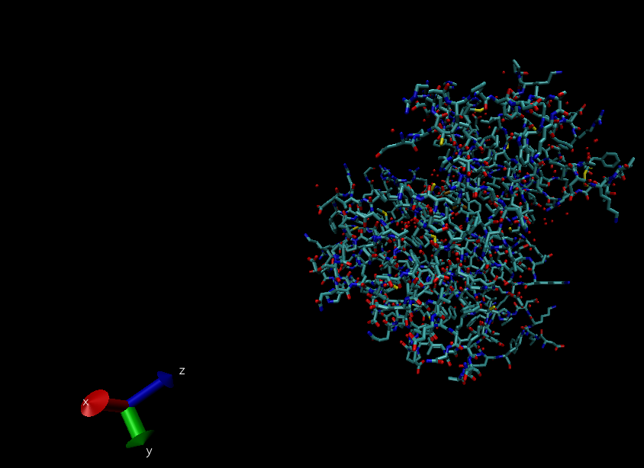

**Question 4**

**Does your protein have crystal waters? If yes, represent using VDW.**

**Directions –** In the main VMD Application, choose Graphics -> Representation -> Selected atoms. Type ‘water’. Set Drawing Method as ‘VDW’.

Yes, the protein 3WZE has crystal waters. They can be visualised as follows.

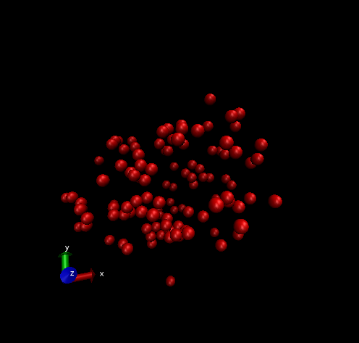

**Question 5**

**Change the background colour to white, hide the axes and render the image in orthographic mode. (Use this layout for answering rest of the questions)**

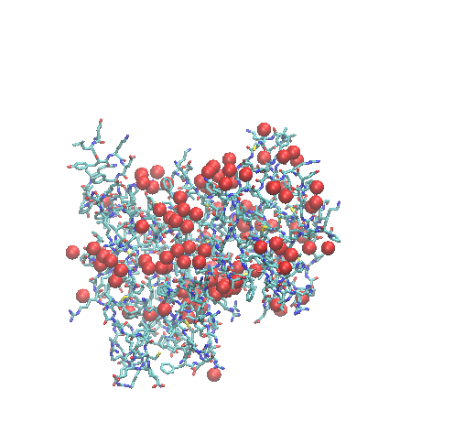

**Question 6**

**Show all hetero atoms (need not include waters) lying within 2.0 Angstrom of your protein in CPK form. List them.**

Hetero atom includes ligands, other small molecules and water molecules. To obtain hetero atoms without water, in the ‘Selected atoms’ panel in the Representations extension, ‘not water and not protein within 2 of protein’ needs to be typed.

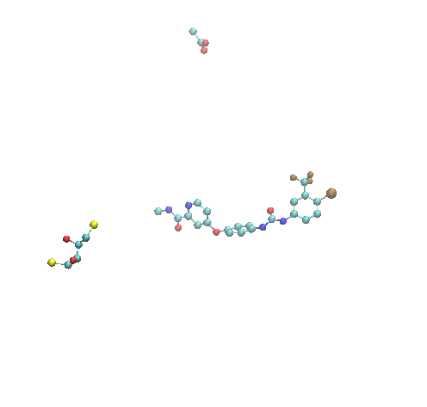

The hetero atoms in this protein – 32 atoms in BAX, 8 atoms in DTT, 4 atoms in ACT.

**Directions -** To find the list of hetero atoms, go to Extensions -> TK console. Type the following commands to first select the required atoms and then get the details.

**Commands –**

set sel [atomselect top "not water and not protein within 2 of protein"]

$sel get {resname index type}

**Result –**

{BAX 2436 C1} {BAX 2437 C2} {BAX 2438 C3} {BAX 2439 C4} {BAX 2440 C13} {BAX 2441 C16} {BAX 2442 C17} {BAX 2443 C18} {BAX 2444 C19} {BAX 2445 C20} {BAX 2446 C21} {BAX 2447 O22} {BAX 2448 C24} {BAX 2449 C25} {BAX 2450 C27} {BAX 2451 C28} {BAX 2452 N30} {BAX 2453 C31} {BAX 2454 C5} {BAX 2455 C6} {BAX 2456 C7} {BAX 2457 F8} {BAX 2458 F9} {BAX 2459 F10} {BAX 2460 CL11} {BAX 2461 N12} {BAX 2462 N14} {BAX 2463 O15} {BAX 2464 C23} {BAX 2465 N26} {BAX 2466 C29} {BAX 2467 O32} {ACT 2468 C} {ACT 2469 O} {ACT 2470 OXT} {ACT 2471 CH3} {DTT 2472 S1} {DTT 2473 C1} {DTT 2474 C2} {DTT 2475 O2} {DTT 2476 C3} {DTT 2477 O3} {DTT 2478 C4} {DTT 2479 S4}

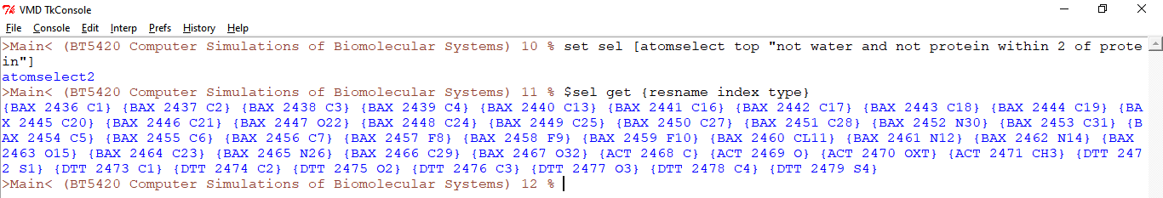

**Question 7**

**Represent in VDW the first atom of your PDB ID using keyword: index and serial. What do you infer from the observation?**

**Directions** – In the main VMD application, choose Graphics -> Representations. Under the white space given for Selected atoms, type ‘index 0’ or ‘serial 1’. This will give you the first atom of the first residue of your protein.

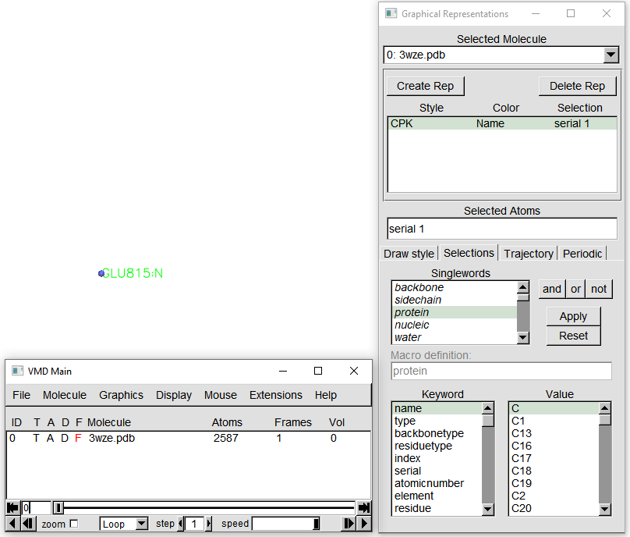

**Question 8**

**Represent the first 5 residues in CPK. Find the angle between any three non-consecutive atoms and display the angle value in red and atom labels in blue.**

**Directions –**In the main VMD application, choose Graphics -> Representations. Under the white space given for Selected atoms, type ‘residue 0 to 4’ to get the first 5 residues of the protein.

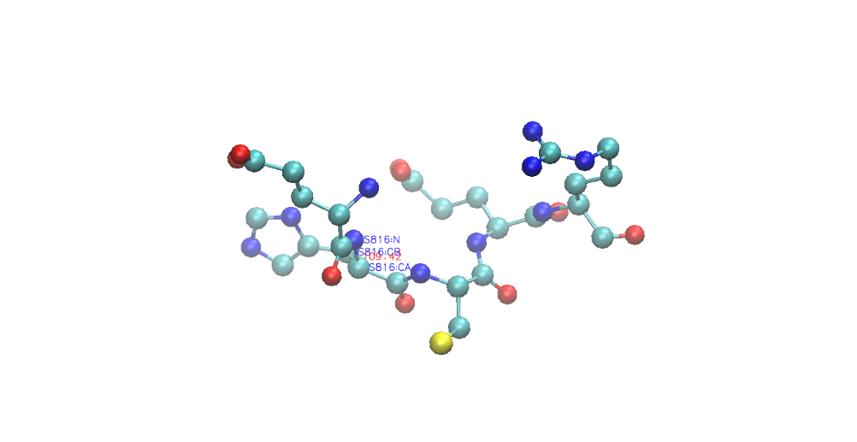

I have computed angle between the N, CA and CB atom of the 2nd residue of the protein PDB: 3wze – HIS 816. The angle was found to be 109.42 degrees.

**Directions** – Select ‘3’ on the keyboard and choose three consecutive atoms. This will display the angle encompassed by the three atoms (2nd atom in the middle). For the colouring scheme, in the main VMD application choose Graphics -> Colours. For setting the angle colour, from the ‘Categories’ section, choose ‘Label’s. In the ‘Names’ section, choose ‘Angles’ and select ‘1 red’ in the ‘Colors’ panel. For setting the atom colours, from the ‘Categories’ section, choose ‘Labels’. In the ‘Names’ section, choose ‘Atoms’ and select ‘0 blue’ in the Colors panel.

**Question 9**

**Load the same PDB twice and place them next to each other in different color.**

**Directions** – Load the first molecule (the protein). Move it a desired position on the white screen. Color the molecule based on color ID. I had also changed the representation of the protein from CPK to Licorice for better depiction. Once this was done, I fixed this protein in space by choosing ‘Toggle Fixed’ under the ‘Molecule’ panel in the main VMD application.

Now load a new molecule of the same protein and follow the above steps. Choose a different color for differentiation.

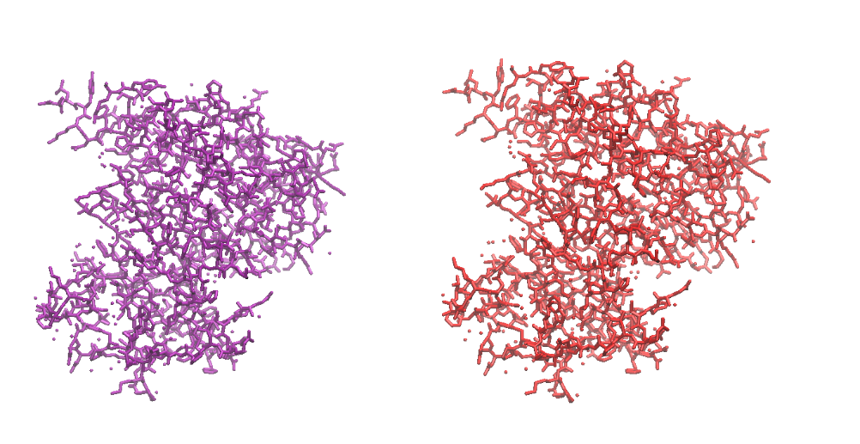

**Question 10**

**Display the contact map of protein. What do you interpret from the graph?**

**Directions –** In the main VMD application, choose Extensions -> Analysis -> Contact map. One the new file opens, click on Calculate -> Calc. res-res Dists.

**Inference –**

* Alpha helix is observed when there are short-range contacts. This is because, in an alpha helical structure, residue ‘i’ is always in contact with {i+1 to i+4}. Therefore, in contact maps, they are identified as strips very close to the main diagonal. Alpha helix is therefore found at the following residues. These are approximate lengths only. –
  + 823 – 832
  + 875 – 893
  + 923 – 930
  + 1001 – 1022
  + 1068 – 1100
  + 1112 – 1122
  + 1132 – 1167
* Lower long-range contacts infer beta sheets. Anti-parallel beta sheets appear as cross diagonal., while parallel beta sheets lie are represented by dots that form a line parallel to the main diagonal. Beta sheets are found at the following positions –
  + 834 – 842
  + 846 – 854
  + 862 – 870
  + 901 – 905
  + 913 – 917
* The other higher long-range contacts infer turns or loops. Loops are represented by breaks in the main diagonal of the contact map.

